Agile Test Summary Report Template

Introduction

The following pages of this document contain a Test Summary Report template, which may be copied and used as the basis of a Test Summary Report for a particular iteration or phase of the test project.

Where text appears within the body of this template in angle brackets (< >), this denotes a place marker, which must be replaced with the appropriate information for a particular testing phase.

Text, which appears in italic, is provided for information only (such as illustrative examples), and should not appear in the final Test Summary Report.

Test Summary Report

Document Information {to <Client> Doc Standard}
Project ID: | Rastaban
Document Ref: | Stepper motor driver tests

Iteration ID:

AUT Title:
Date: | 29-09-2022

Distribution
Copy Number | Recipient
1. | <recipient 1>
2. | <recipient 2>
3. | <recipient 3>
 | etc.
N. | Project File

Contents

1 Introduction

2 Overview

3 Variances

4 Assessment

5 Results

6 Evaluation

7 Summary of Activities

1 Introduction

1.1 Background

This document provides the Test Summary for the testing activities within iteration Rastaban HAT V1.0

The goal of this test is to determine the functionality and usability of the A4988 and the tmc2209 stepper motor driver.

1.2 Structure of the Report

This report is structured in the following manner:

Section 2, Overview, provides an overview of the significant events and activities documented within the Rastaban HAT testing of the Rastaban project

Section 3, Variances, records any variances of the artefacts from those areas agreed on previously, especially in areas that may cause concern to the group accepting the test results, including any references to supporting documentation that covers the reasons for the deviations

Section 4, Assessment, provides a brief assessment of the comprehensiveness of the testing process for the Rastaban HAT testing of the Rastaban project

Section 5, Results, provides a summary of the results of the Rastaban HAT testing of the Rastaban project

Section 6, Evaluation, provides an overall evaluation of the testing process including any observed problems and/or limitations

Section 7 provides a summary of the major testing activities and events for the Rastaban HAT testing of the Rastaban project

1.3 References

A list of documents referenced within this Test Summary Report document.

2 Overview

This section provides a high level overview of the significant events and activities documented during the Rastaban HAT testing of the Rastaban project.

This section also specifies the scope of the testing (what was and what was not tested), and specifying the test environment details (including the hardware, software and data used in the testing).

The testing was conducted with a windows laptop running the Arduino IDE and all code was run on a Arduino UNO R3. The supplied voltage to the driver was 12V for the motor and the Arduino received 5V from an USB cable.

Test setup:
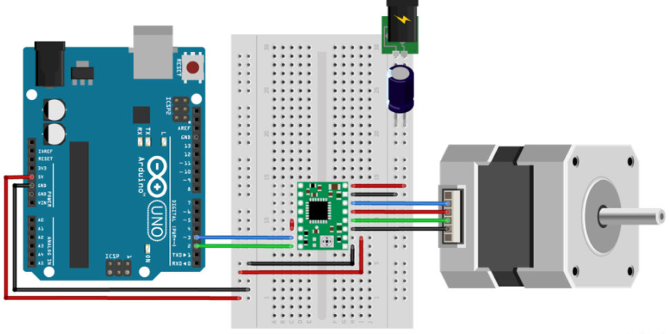

Code:
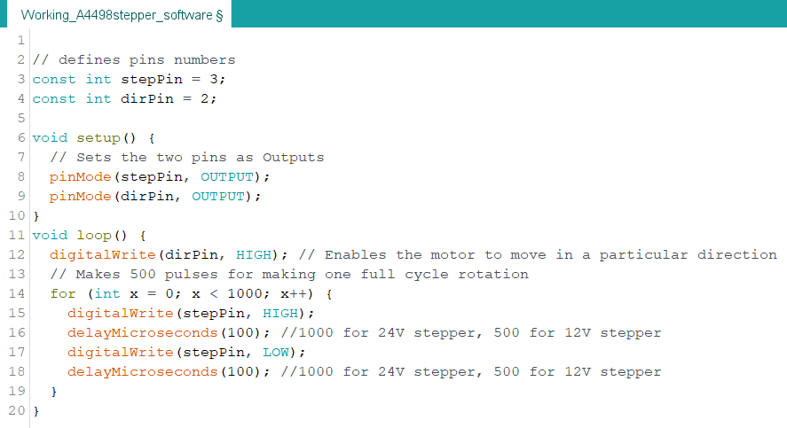

3 Variances

This section is used to record any variances of the artefacts from those areas agreed on previously, especially in areas that may cause concern to the group accepting the test results, including any references to supporting documentation that covers the reasons for the deviations.

The motor drivers are being tested on a breadboard, which may cause some reliability and test outcome questions. The reason for choosing this method is to not waste time on soldering all components together and having to desolder them afterwards.

4 Assessment

This section provides a brief assessment of the comprehensiveness of the testing process for the completed testing phase against the test objectives and constraints specified in the Test Plan document.

Where code coverage measurements have been made, the results should also be included in this section.

This section also identifies any aspects of the AUT that were not tested as thoroughly as planned (due to insufficient time or resources).

Testing of the extra features of the tmc2209 where omitted since these features are not required for the basic functionality of the Rastaban.

5 Results

This section provides a summary of the results of the Rastaban HAT testing of the Rastaban project, identifies all resolved issues and summarises the details of their resolution, and lists any outstanding issues.

The TMC2209 seems operate quieter than the A4988, but at the cost of using more current. This may be due to the fact that the TMC2209 requires a different control signal, since the current draw went down with some frequencies. This seems to be very important and searching for the most efficient switching frequency is advisable. Both seem to be adequate to provide fluid movement in the Rastaban, however the TMC2209 has a higher stepping frequency, offers more features, runs quitter, and provides feedback to the MCU if requested and therefore seems the better option on paper.

6 Evaluation

This section provides an overall evaluation of the testing process including problems and limitations.
The drivers seem to require a rather specific switching frequency. If the frequency is not to the stepper drivers liking, the tmc2209 will get hot after around 3 minutes and so does the stepper motor. Thankfully the motors are not being driven for extended periods so this could may as well be neglected if the problem can not be resolved.

7 Summary of Activities

This section provides a summary of the major testing activities and events for the Rastaban HAT testing of the Rastaban project. This section also summarises testing resource information, such as total staffing levels, total testing time, etc.

For Example:

Test Start Date: 24-09-2022 Test End Date: 29-09-2022
Item | Planned | Actual
Staff Levels | 3 | 2
Test Design Effort | 1.5 | 0.6
Test Execution Effort | 2 | 8
Re-Test Effort | 0 | 0.
Test Management and Reporting | 1 | 1.5

Etc.

